How to create new columns existing dataframe

Adding a new column to a DataFrame in Pandas is a simple and common operation when working with data in Python. You can quickly create new columns by directly assigning values to them. 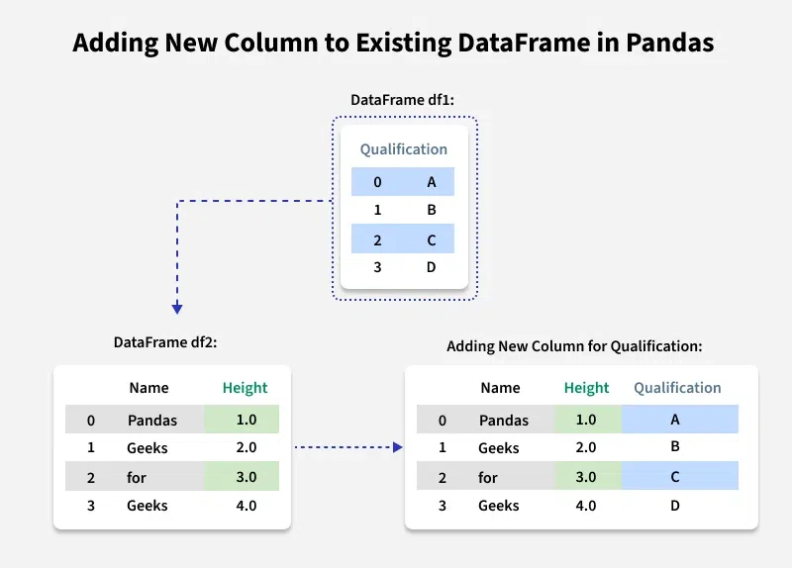

## By Declaring a New List as column

Let's first create a dataframe

import pandas as pd

# Define a dictionary containing Students data

Data2 = {'Name': ['Pandas', 'Geeks', 'for', 'Geeks'],

'Height': [1, 2, 3, 4],

'Qualification': ['A', 'B', 'C', 'D']}

# Convert the dictionary into DataFrame

df = pd.DataFrame(data2)

We can simply add new column to the DataFrame with the specified list values. Note that the length of your list should match the length of index column, else it will show an error.

# Declare a list that is to be converted into a column

address = ['NewYork', 'Chicago', 'Boston', 'Miami']

# Using 'Address' as the column name

# and equating it to the list

df['Address'] = address

display(df)

Output

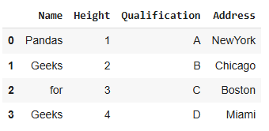

Adding New Column to Existing DataFrame in Pandas

**Adding a new column to existing DataFrame in Pandas in Python**

**Steps**

1. Create DataFrame using a dictionary.

2. Create a list containing new column data. Make sure that the length of the list matches the length of the data which is already present in the data frame.

3. Add the list to the DataFrame like dictionary element.

print('create a new column to the existing column in dataframe ')

print('create a dictionary')

import pandas as pd

data3={

    'Name':['Pandas','Loc','Lio','Geeks'],

    'Height':[22,12,23,11],

    'Qualification':['Mba','Ca',"data A",'Doc'],

    'price':[200,300,400,500]

}

print('convert dictionary into dataframe')

print('before adding new column')

df=pd.DataFrame(data3)

display(df)

print('\n')

print('create a new column in existing dataframe')

df['price change']=df['price']*40

df

output

Output

create a new column to the existing dataframe

create a dictionary

convert dictionary into dataframe

before adding new column

|  | **Name** | **Height** | **Qualification** | **price** |
| --- | --- | --- | --- | --- |
| 0 | Pandas | 22 | Mba | 200 |
| 1 | Loc | 12 | Ca | 300 |
| 2 | Lio | 23 | data A | 400 |
| 3 | Geeks | 11 | Doc | 500 |

create a new column in existing dataframe

|  | **Name** | **Height** | **Qualification** | **price** | **price change** |
| --- | --- | --- | --- | --- | --- |
| 0 | Pandas | 22 | Mba | 200 | 8000 |
| 1 | Loc | 12 | Ca | 300 | 12000 |
| 2 | Lio | 23 | data A | 400 | 16000 |
| 3 | Geeks | 11 | Doc | 500 | 20000 |

## DataFrame.insert()

There is a built-in method called insert() to add a new column.

### steps

1. Create DataFrame using dictionary.

2. Create a list containing new column data. Make sure that the length of the list matches the length of the data which is already present in the data frame.

3. Insert the data into the DataFrame using DataFrame.insert(index, column_name, data) method.

#import pandas

import pandas as pd

# craete dataframe

data4={

    'Name': ['Hafeez', 'Aslan', 'Kareem'],

   'Age': [19, 18, 15],

   'Profession': ['Pythoneer', 'Programmer', 'Student']

}

dataframe=pd.DataFrame(data4)

print('*****************before add new column***************')

print(dataframe)

print('\n')

print('craete a new list')

address=['jalandhar','amritsar','pune']

# now use address column in existing dataframe gives the index number where we want to insert

dataframe.insert(2,'person address',address)

print('********************************after add new column************')

print(dataframe)

Output

*****************before add new column***************

Name Age Profession

0 Hafeez 19 Pythoneer

1 Aslan 18 Programmer

2 Kareem 15 Student

craete a new list

********************************after add new column************

Name Age person address Profession

0 Hafeez 19 jalandhar Pythoneer

1 Aslan 18 amritsar Programmer

2 Kareem 15 pune Student

## DataFrame.assign()

This method takes one argument i.e., a list of data and adds it to the data frame as a column at the end.

### steps

1. Create DataFrame using a dictionary.

2. Create a list containing new column data. Make sure that the length of the list matches the length of the data which is already present in the data frame.

3. Insert the data into the DataFrame using DataFrame.assign(column_name = data) method. It returns a new data frame. So, we have to store it.

4. Print the new data frame.

#import pandas

import pandas as pd

# craete dataframe

data4={

    'Name': ['Hafeez', 'Aslan', 'Kareem','sunita'],

   'Age': [19, 18, 15,32],

   'Profession': ['Pythoneer', 'Programmer', 'Student','wife']

}

dataframe=pd.DataFrame(data4)

print('*****************before add new column***************')

print(dataframe)

print('\n')

print('craete a new list')

address=['jalandhar','amritsar','pune','pape']

# now use assigning address column in existing dataframe

new_dataframe=dataframe.assign(PeopleAddress=address)

print('********************************after add new column************')

print(new_dataframe)

output

*****************before add new column***************

Name Age Profession

0 Hafeez 19 Pythoneer

1 Aslan 18 Programmer

2 Kareem 15 Student

3 sunita 32 wife

craete a new list

********************************after add new column************

Name Age Profession peopleAddress

0 Hafeez 19 Pythoneer jalandhar

1 Aslan 18 Programmer amritsar

2 Kareem 15 Student pune

3 sunita 32 wife pape

## Add Multiple Columns in Dataframe at once (By using Dictionary Method)

We can use a [Python dictionary](https://www.geeksforgeeks.org/python/python-dictionary/) to add a new column in pandas DataFrame. This method is recommended when you want to add multiple columns at once or if you have columns in a dictionary format.

# import pandas

import pandas as pd

# Define dictionary defined as studen data

student={

    'Name':['Pandas', 'Geeks','For','david'],

    'cals':['2nd','3rd','4th','5th'],

    'rollno':[100,200,300,202]

}

# Convert the dictinory in the data frame

df=pd.DataFrame(student)

# now create a ned dictionary name as address with the key and address value

address={

    'Pandas':'NewYork','Geeks':'Delhi','For':'Denmark','david':'Chicago'

}

# Now add address column by mapping the 'Name' column

# add address dictinot=ry in the existing dataframe

df['Address']=df['Name'].map(address)

print(df)

output

Name cals rollno Address

0 Pandas 2nd 100 NewYork

1 Geeks 3rd 200 Delhi

2 For 4th 300 Denmark

3 david 5th 202 Chicago

Add Multiple Columns in Dataframe at once (By using Dictionary Method)

We can use a Python dictionary to add a new column in pandas DataFrame. This method is recommended when you want to add multiple columns at once or if you have columns in a dictionary format.

#add two new column in the existing dataframe

new_column={

    'Age':[22,33,23,44],

    'Qualification':['MBA','CA','Doctor','Nurse']

}

# now unpack or add these two column in the existing dataframe

df=df.assign(**new_column)

print(df)

output

Name cals rollno Address Age Qualification

0 Pandas 2nd 100 NewYork 22 MBA

1 Geeks 3rd 200 Delhi 33 CA

2 For 4th 300 Denmark 23 Doctor

3 david 5th 202 Chicago 44 Nurse

By using Dataframe.loc()

Using .loc[], you can add a new column directly or modify values based on conditions, or when adding new columns based on specific row selections.

# import pandas

import pandas as pd

#create dictinory as company data

company={

    'Name':['arya','dario','cola','fanta'],

    'no_of_employee':[22,22,44,100],

    'Average_salary':[3000,2000,3200,2000]

}

# convert dictinory in data frame

df=pd.DataFrame(company)

print('-----------before apply condition data shows-------------')

print(df)

#using .loc() function add new column category

df.loc()[df['Average_salary']>2500,'Category']='Good'

df.loc()[df['Average_salary']<2500,'Category']='less average'

print('----------after column addition-----------')

print(df)

output

-----------before apply condition data shows-------------

Name no_of_employee Average_salary

0 arya 22 3000

1 dario 22 2000

2 cola 44 3200

3 fanta 100 2000

----------after column addition-----------

Name no_of_employee Average_salary Category

0 arya 22 3000 Good

1 dario 22 2000 less average

2 cola 44 3200 Good

3 fanta 100 2000 less average